User Guide for Monkey Music Box

Version Pro 1.0
Wenyi zou
August 27, 2014
Monkey Music Box Overview

This box is for the prostheticst using in prosthetic socket.

The whole box will be inside a monkey. The wire coming out will be connected to a force sensor resister. Put the sensor in to prosthetic socket. When patient try to fit the socket, with some certain pressure on sensor, the box will play sound that stored before to indicate the right fitness of patient.

Patient here especially means baby and kid.

Monkey Music Box Layout

Front side:
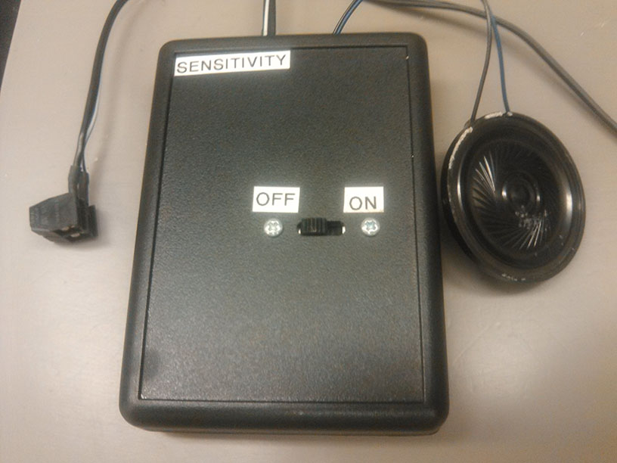
Front side contains:
- Power switch

Top side:
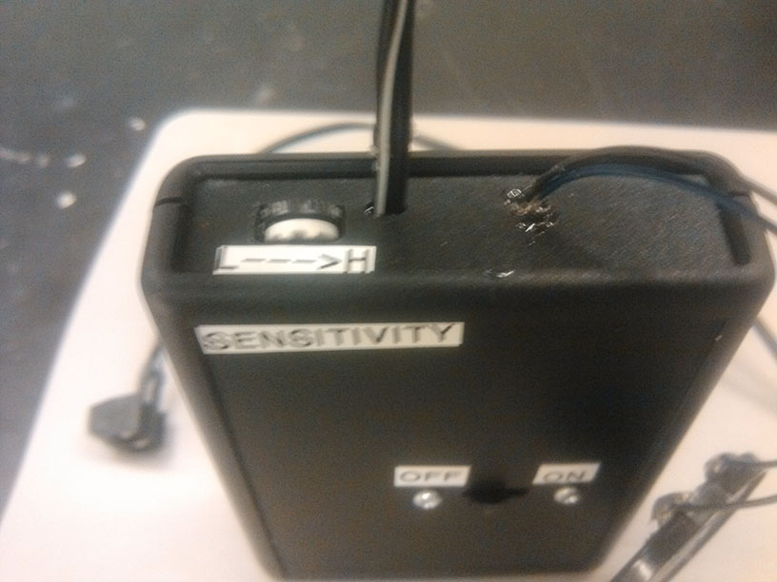
Top side contains:
- Sensitivity knob.
- Screw terminal wire.
- Speaker wire.
Back side:
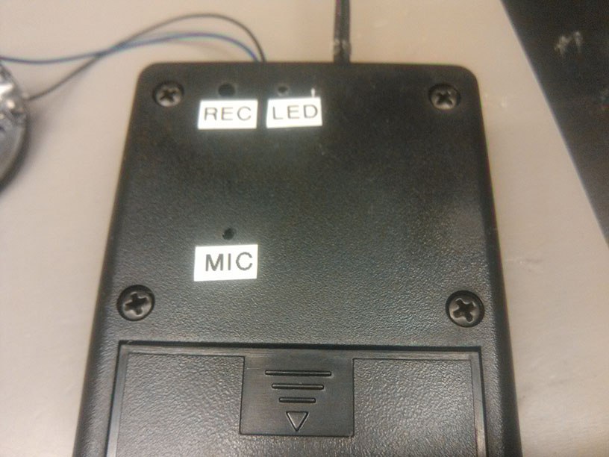
Back side contains:
- Recorder button hole.
- Led indicator hole.
- Microphone hole.
- Battery cover.

Screw terminal:
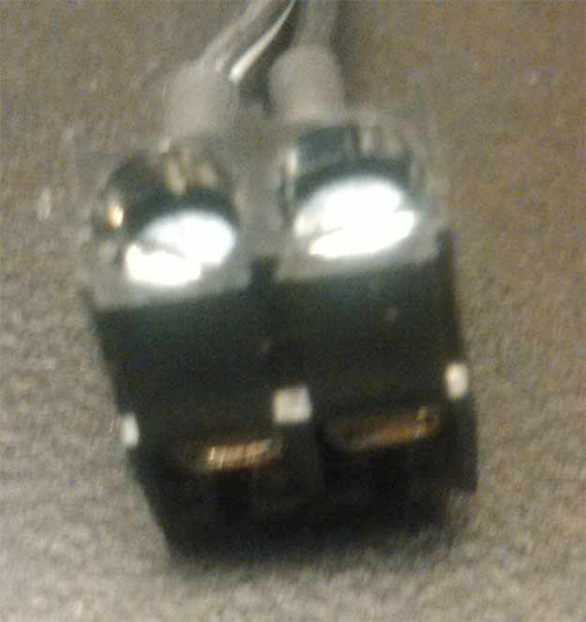
Inside:
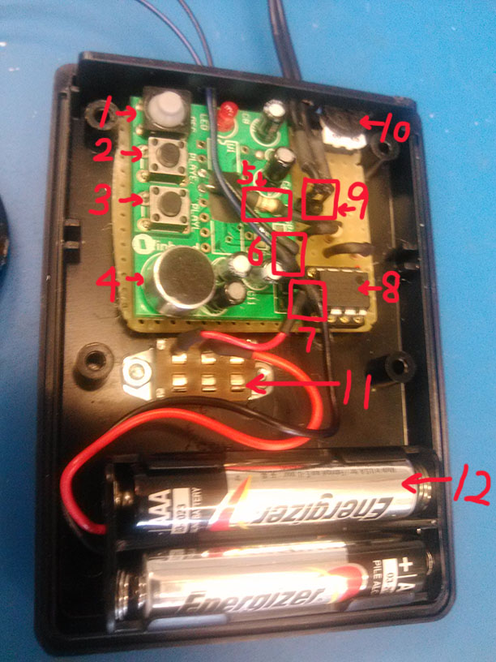
Inside contains: Music Board, switch, battery socket.
- Rubber button for recording.
- Edge triggered play sound button.
- Level triggered play sound button, low lever trigger.
- Microphone for recording.
- Connection resistor, for sending trigger signal from LM393 to level triggered connector. Resistance suggest from 1Kohm to 10Kohms.
- Speaker wire connector.
- Power wire connector.
- LM393 comparator
- Force sensor resistor connector.
- Potentiometer, use for sensitivity adjustment.
- Power switch.
- Battery socket.
Step for Using Box

- Connect force sensor resistor(FSR) to screw terminal.
- Open battery cover, put 2 AAA batteries, close battery cover.
- Turn on the power switch.
- Press the FSR and adjust the sensitivity knob in a good position according to specific requirement, until it play sound.
- Put FSR inside prosthetic socket and use.

Note:
- When playing sound, the LED will keep blinking. And in order to play the whole sound, FSR should be press all the time without lose.
- Sensitivity knob is not a linear device, the more it get close to low sensitivity, the smaller turning is needed.
- Don’t pull the wire.

Step for Changing Sound
- Turn on the power switch.
- Use pen or some stick have similar size as REC hole, push down the inside rubber button.
- When the box is recording, the LED will keep light until release the button, which means finish record.

Note:
- Please use some stick have similar size to push, it’s not recommend to use some thin pin to push. For one aspect, it may damage the button, for the other aspect, thin pin may not totally push down the button and thus the recording will fail.
- When recording, please don’t block MIC hole.

Monkey Music Box Operation Principle

Power:
The power is supplied by 2 AAA batteries, 3V. However, the board itself can operate at the voltage between 2.4V to 5.5V.

Sound trigger:
This box actually use LM393 comparator to compare two input voltage and then give an output to resistor 5 and to the connector on board, which is the same spot as level triggered button.

The comparator’s negative input is half of Vcc that divided by two same value resistor. The positive input is voltage on FSR. The voltage on potentiometer(sensitivity knob) plus voltage on FSR is Vcc. Schematic is shown below.

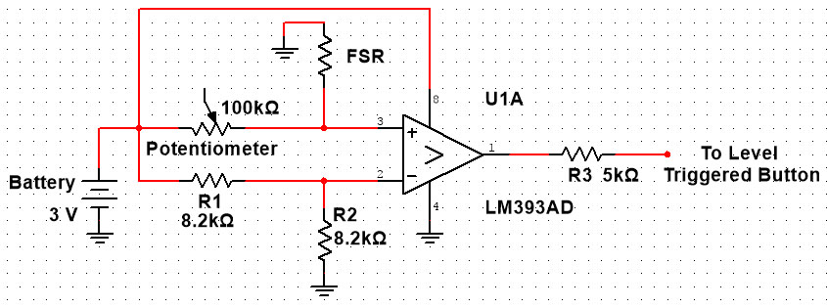

The resistance of FSR using here will reduce when press, which means the voltage on FSR will decrease. When the voltage on FSR decrease to half of Vcc, the trigger signal(low active) send, and the box will play sound.

Change potentiometer:
The potentiometer is plugged into a 3 pins socket, not soldered, so it’s really convenient to change potentiometer.

The aim for changing potentiometer is for adjust the sensitivity level. For normal FSR(from 40Mohms to 100Ohms around), the normal resistance when press will be around 5Kohms to 200Kohms depends on the pressure(normal hand or arm press pressure).
So it’s recommend to choose potentiometer as 5K, 10K, 20K, 50K, 100K, 200K to match the specific requirement.

